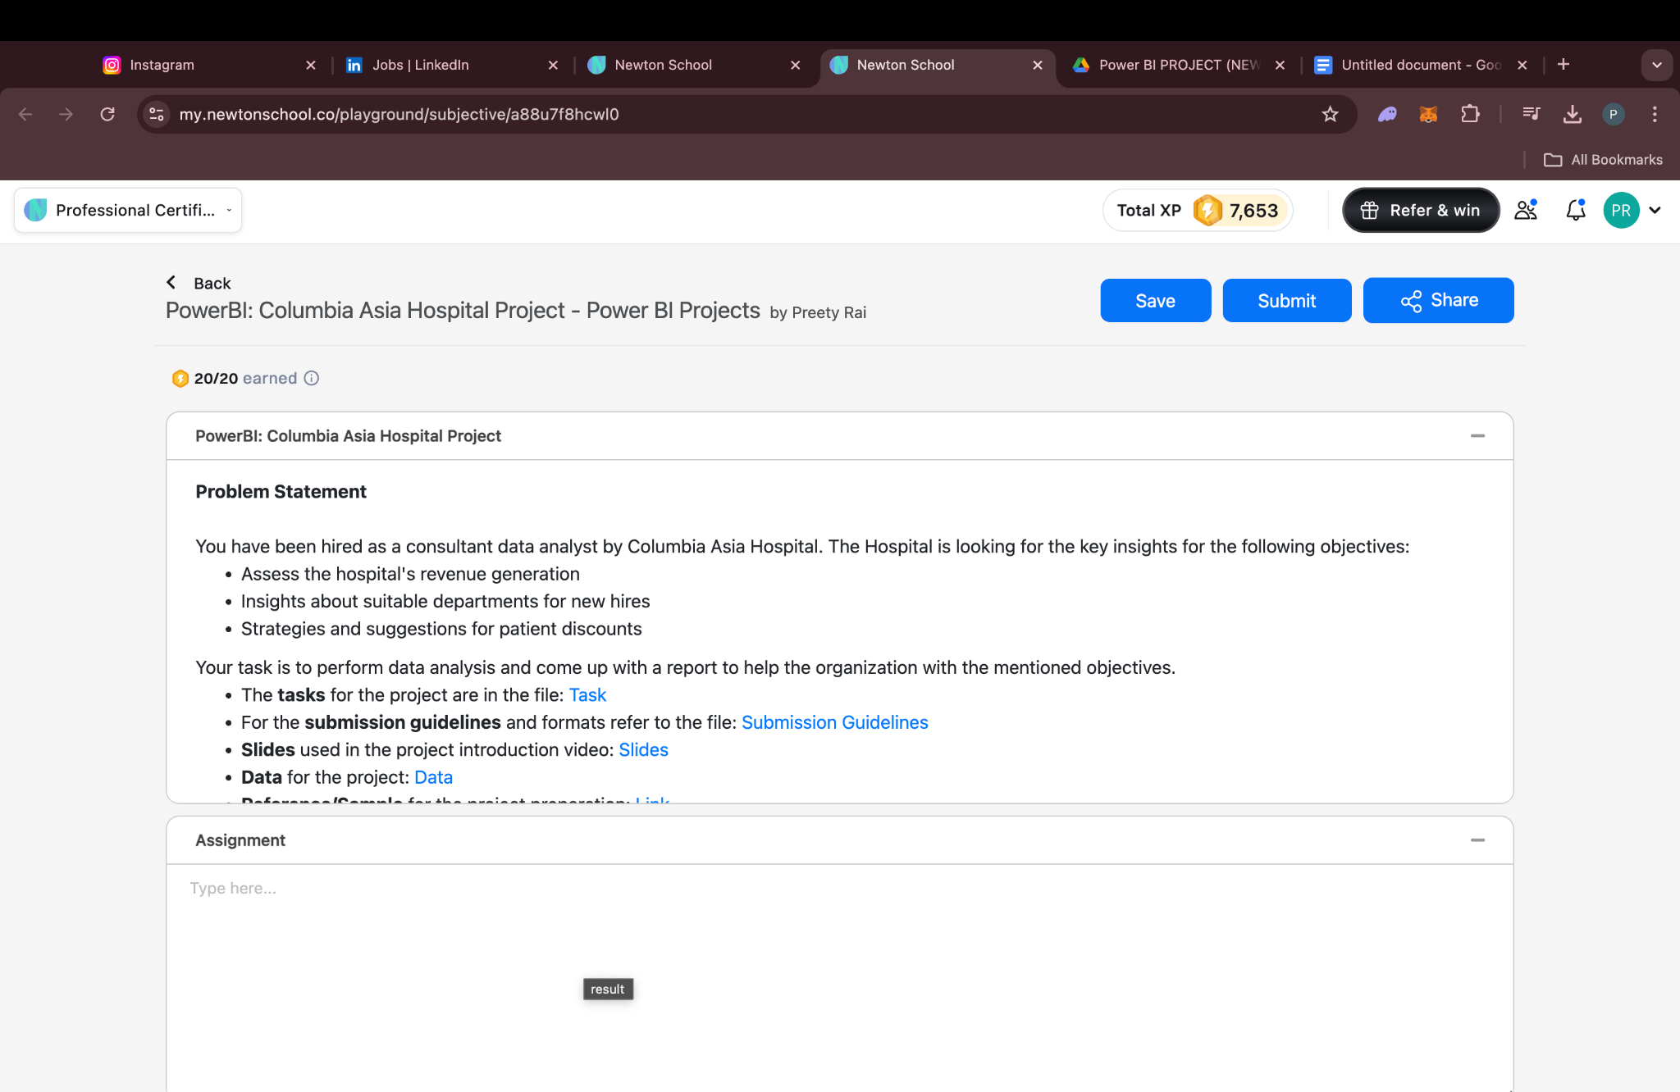

Tasks:- <https://docs.google.com/document/d/1e8jrMgwDsShXfGlYEpvPVbSJYxyCkH8w/edit?usp=sharing&ouid=106821585961273059170&rtpof=true&sd=true>

Submission Guidelines:-

https://docs.google.com/document/d/1ZVKczIH380V_d4xTyzusRN0CITyTdzwjm6Hl_iI-7C0/edit?usp=sharing